MAIN PAGE

SIDING & SOFFIT
Industrial / Residential / Commercial
Enhance the aesthetic and functional appeal of your Industrial, residential or commercial property with our high-quality siding solutions. At Cladcan, we offer a wide range of siding materials designed to meet diverse architectural needs and performance requirements. Our products ensure durability, energy efficiency, and exceptional visual appeal, making them ideal for any building project.
Find the ideal match for your project with our impressive array of offerings!
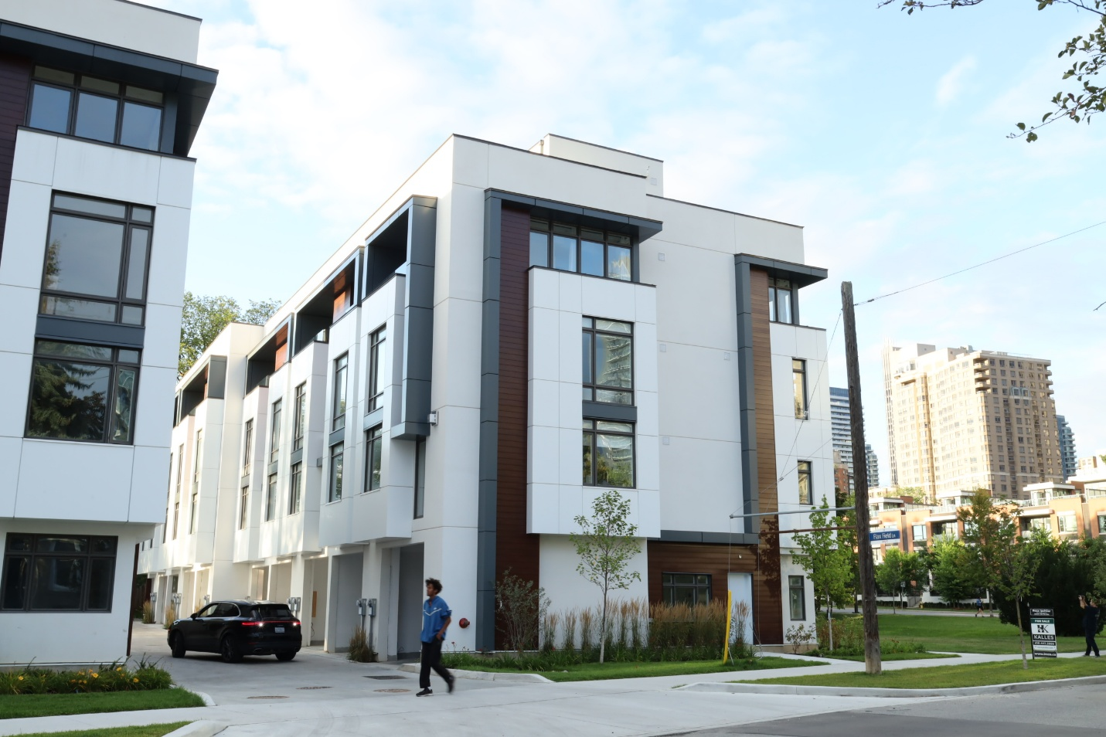

SIDING & SOFFIT MENU ICON (PREVIEW)

Aluminum Siding & Soffit
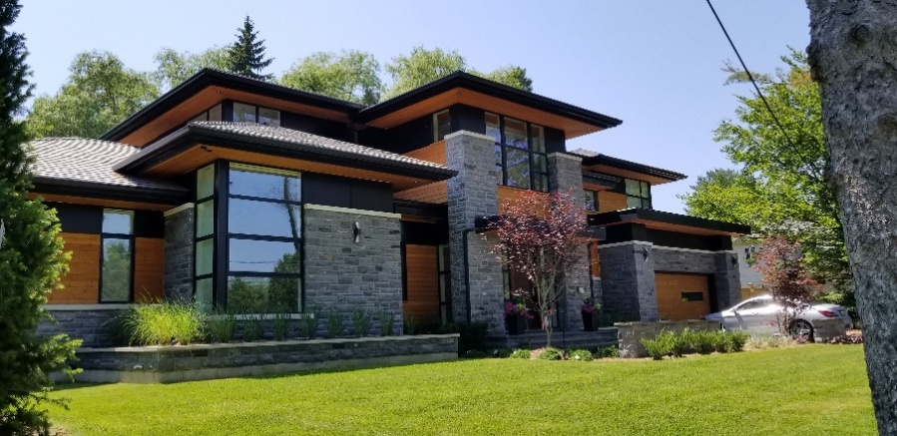
Our premium aluminum siding & soffit solutions are meticulously crafted to elevate both the aesthetic allure and structural fortitude of your project, seamlessly marrying elegance with practicality. (Learn More- Expand)
Expanded …Our aluminum siding & soffit boasts an extensive palette of colors and textures, providing robust protection against the elements while enhancing your build’s visual charm. Delve into our Aluminum panel choices to uncover how our cutting-edge siding options that can redefine your living & working spaces with enduring sophistication and effortless upkeep.
Curious about the advantages of aluminum siding? Visit our blog to explore the compelling reasons why this choice stands out for homeowners seeking durability and style.
Speak with an Expert
Get personalized advice and expert guidance to achieve your project goals with confidence.

1- ARCHITECTURAL BATTENS MENU ICON (PREVIEW)

Premium-quality Privacy Screens with rich Woodgrain & Solid finishes.
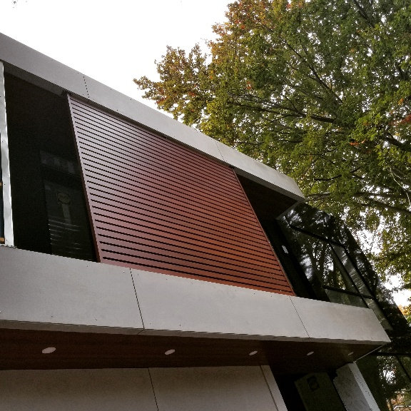
CladCan’s aluminum battens offer both exceptional performance and effortless installation. (Learn More / Expand)

- 1 ARCHITECTURAL BATTENS PAGE (EXPANDED)
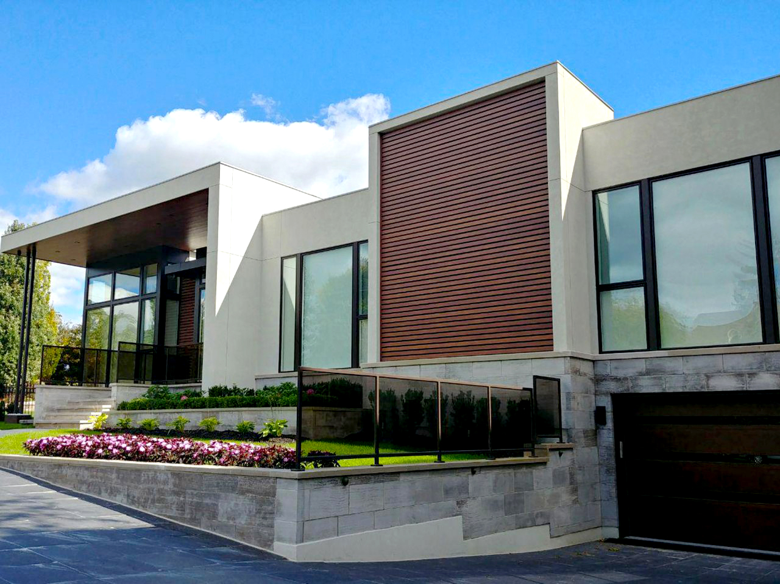
Expanded … CladCan’s aluminum battens offer both exceptional performance and effortless installation. Designed to give architects and designers the freedom to create limitless architectural forms, these battens can be installed on nearly any surface—whether mounted horizontally or vertically on walls, suspended from ceilings, or used for privacy screens and other applications. They function just like traditional wood planks, requiring no specialized tools for installation. Depending on project needs, the battens can be drilled or threaded, with the flexibility to attach various brackets on any side and in any direction.

BENEFITS
• Quick and effortless batten installation
• Lightweight, easy to handle, and simple to cut
• Available in standard 16′ length, with options for 12′ and 8′
• Zero maintenance required
• Fire-resistant and corrosion-proof
• Backed by a lifetime warranty

Available Sizes
Standard Length: 16’
Also available in 8’ and 12’
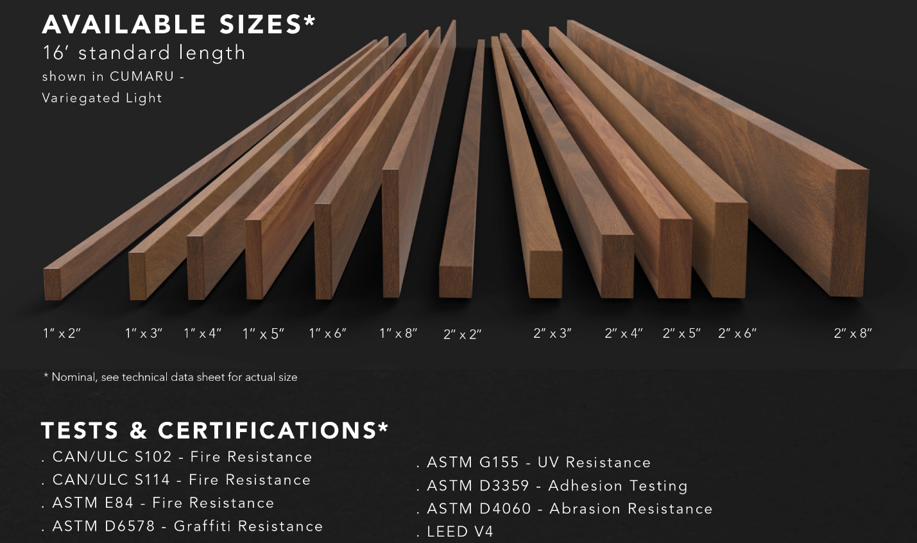

Brackets Options
CladCan offers three bracket types tailored for different installation types, whether horizontal, vertical, or mounted on ceilings, walls, or the ground.
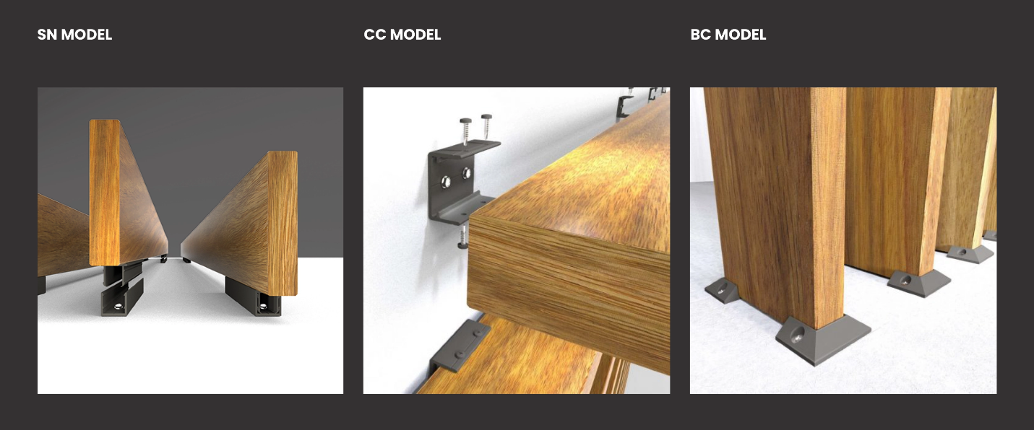
Designed for both security and aesthetics, the brackets ensure a reliable and visually appealing attachment solution:
SM Model
CC Model
BC Model

Texture and Colours
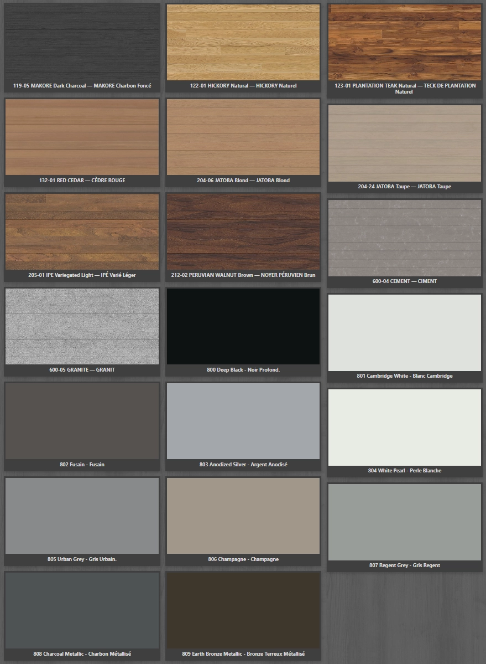
Speak with an Expert
Get personalized advice and expert guidance to achieve your project goals with confidence.

